🔹 In Real Industry
Before development starts:
- Business Analyst gathers requirements.
- They prepare the SRS document.
- Client reviews it.
- After approval, development begins.
So SRS becomes a reference document for:
- Developers
- Testers
- Project managers
Testers even write test cases based on SRS.

✅ SRS
SRS is like a normal document file.
It can be:
- Word document
- PDF
- Google Doc
- Confluence page

🔹 Who is it for?
It is mainly prepared between:
- Client → The person or company who needs the software
- Development team → The people who will build the software
It acts like an agreement.
Both sides understand what will be built.

🔹 What does it contain?
It clearly explains:
1️⃣ Features the system must provide
Example:
- User login
- Database connection
- Report generation

2️⃣ Business rules
These are rules that must be followed.
Example:
- User must enter valid email format
- Order cannot be placed without payment
- Student age must be above 18

3️⃣ Functional requirements
These explain what the system should do.
Example:
- System must allow user registration
- System must store data in database
- System must generate invoice

4️⃣ Non-functional requirements
These explain how well the system should work.
Example:
- System should respond within 2 seconds
- System should support 10,000 users
- System should be secure

5️⃣ Constraints and assumptions
Constraints → Limitations
Example:
- Must use Java
- Must run on Windows
- Must use MySQL database
Assumptions → Things we expect to be true
Example:
- Users have internet connection
- Server will be available 24/7

✅ Jira
Jira is used to:
- Break requirements from srs into tasks
- Assign work to developers
- Track progress
- Track bugs
- Manage project workflow
Jira is more about:
Managing work
not
Writing full formal documents

Instead of directly writing logic inside class,
you define a contract.
Example:
public interface UserService {
boolean login(String email, String password);
}
This interface says:
Any class that handles user login MUST provide login() method.
It defines WHAT must be done.
It does not define HOW.

🔹 See the Pattern?
Level | Defines | Implementation?
SRS | What system must do | ❌ No
Jira | What tasks must be done | ❌ No
Interface | What methods must exist | ❌ No
Class | How it is implemented | ✅ Yes

🔹 Real Flow Example
SRS says:
System must support multiple payment providers.
As a developer, you design:
public interface PaymentService {
void processPayment(double amount);
}
Then you implement:
public class CreditCardPayment implements PaymentService {
public void processPayment(double amount) {
// credit card logic
}
}
public class UpiPayment implements PaymentService {
public void processPayment(double amount) {
// UPI logic
}
}
Now your system is flexible.
If tomorrow new provider comes,
you just add new implementation.
SRS requirement stays same.
Interface contract stays same.
Only implementation changes.

🎯 Final Big Understanding
SRS → Contract at business level
Interface → Contract at code level

1️⃣ What is an Interface in Java?
An interface in Java is a contract.
It tells:
“These are the methods that must be available.
I don’t care how you implement them.”
It contains:
- Method declarations (no body)
- Constants (public static final by default)
Eg: interface DatabaseConfig {

// Compiler automatically makes this:
// public static final int PORT = 3306;

int PORT = 3306; // same as public static final
}
It does not contain implementation logic (normally).
So we can say:
An interface defines what should be done,
not how it should be done.

3️⃣ How JDBC Relates to Interface
Now let us connect everything with your diagram.
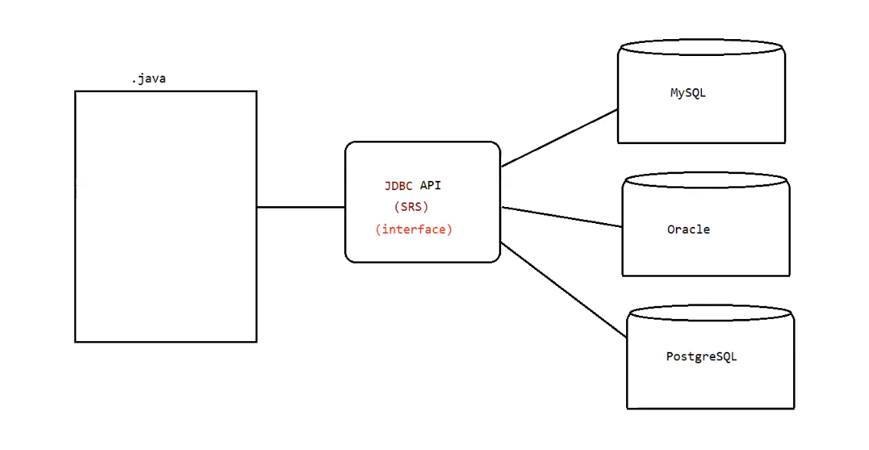

What is happening?
- You write one Java program
- Your program talks to JDBC API
- JDBC API talks to:
  - MySQL
  - Oracle
  - PostgreSQL
You do NOT write 3 different programs.
You only change the driver.

🔹 🔗 Linking This to SRS (New Connecting Point)
Now imagine the SRS says:
The system must connect to a database.
The system must execute queries.
The system must support different database vendors.
This is written at requirement level.
Now at design level, developers think:
“How do we support multiple databases without changing our main code?”
The answer is:
👉 Use an interface-based design (JDBC).
So:
SRS requirement
↓
Design decision: Use JDBC interfaces
↓
Drivers implement the interfaces
That means:
SRS defines what system must support
JDBC interface helps us design how to support it in a flexible way
So JDBC becomes the technical solution to satisfy the SRS requirement.

4️⃣ What is JDBC Actually?
JDBC (Java Database Connectivity) is an API.
An API means:
A collection of ready-made classes and interfaces.
JDBC provides important interfaces like:
- Connection
- Statement
- PreparedStatement
- ResultSet
- Driver
These are all interfaces.
They define:
- how to connect
- how to execute query
- how to get result
But they do NOT implement database-specific logic.

5️⃣ Who Implements These Interfaces?
Database vendors implement them.
Example:
- MySQL provides: MySQL Driver
- Oracle provides: Oracle Driver
- PostgreSQL provides: PostgreSQL Driver
Each driver implements JDBC interfaces.
So:
JDBC Interface → Implemented by → MySQL Driver
JDBC Interface → Implemented by → Oracle Driver
JDBC Interface → Implemented by → PostgreSQL Driver
That is why your same Java code works for different databases.

3️⃣ How Servlet API Relates to Interface
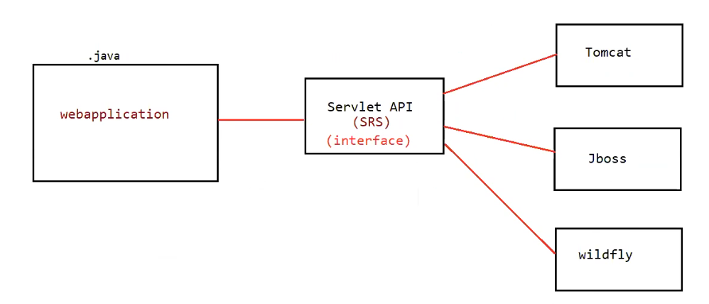
🔹 What is happening?
- You write one web application (Servlet-based).
- Your application talks to Servlet API.
- The server (container) implements the Servlet API.
- The server can be:
  - Tomcat
  - JBoss
  - WildFly
You do NOT write 3 different web applications.
You only deploy the same application on different servers.

🔹 Important Clarification
Your web application does run on JVM.
But it does not run as a standalone program like:
java MyProgram
It runs inside a Servlet Container / Application Server.
That server internally runs on JVM.
So:
Web App → runs inside Server
Server → runs on JVM

🔗 Linking This to SRS (Very Important)
Now imagine the SRS says:
- The system must handle HTTP requests.
- The system must generate HTTP responses.
- The system must run on different servers.
- The system must be portable across application servers.
This is written at requirement level.
Now developers think:
“How do we build a web application that works on different servers without changing code?”
The answer is:
👉 Use Servlet API (interface-based design)
So the flow becomes:
SRS requirement
↓
Design decision: Use Servlet API
↓
Servers implement the API
That means:
- SRS defines what system must support.
- Servlet API provides the technical contract.
- Servers implement that contract.
Servlet API becomes the technical solution to satisfy the SRS requirement.

4️⃣ What is Servlet API Actually?
Servlet API is an API provided by Java.
An API means:
A collection of ready-made interfaces and classes.
Important interfaces in Servlet API:
- Servlet
- GenericServlet
- HttpServlet
- ServletRequest
- ServletResponse
- ServletConfig
- ServletContext
These define:
- How to receive request
- How to send response
- How to manage lifecycle
- How to configure servlet
But they do NOT implement server-specific logic.

5️⃣ Who Implements These Interfaces?
Application servers implement them.
Example:
- Tomcat implements Servlet API
- JBoss implements Servlet API
- WildFly implements Servlet API
So:
Servlet Interface → Implemented by → Tomcat
Servlet Interface → Implemented by → JBoss
Servlet Interface → Implemented by → WildFly
Your code depends only on the Servlet API.
The server provides the actual implementation.

Example: 3
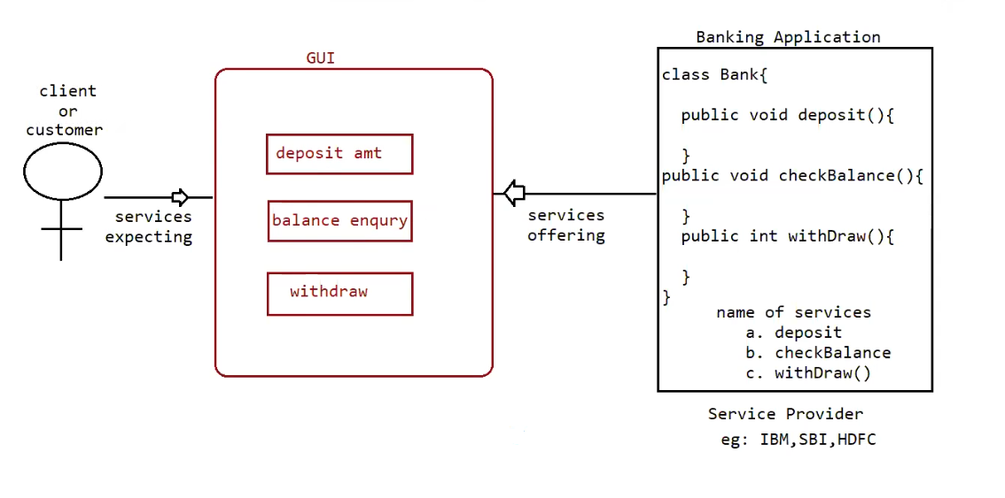

✅ Definition of Interface (Client & Service Provider View)
🔹 From Client Point of View
An interface defines:
The set of services the client is expecting.
Example (ATM customer):
- Deposit money
- Withdraw money
- Check balance
The customer does not care how the bank internally works.
He only cares that these services must be available.

🔹 From Service Provider Point of View
An interface defines:
The set of services the provider is offering.
Example (Bank):
The bank says:
- We provide deposit()
- We provide withdraw()
- We provide checkBalance()

🔗 Linking This to Interface in Java
Now in Java we write:
interface Account {

void withDraw();
void deposit();
void checkBalance();
}
This interface defines:
- withdraw()
- deposit()
- checkBalance()
It does NOT define logic.
It only defines the service list.
This is exactly like ATM service list.

🔹 Important Concept: 100% Abstraction
Through class:
- We can have abstract methods
- We can have concrete methods
- So 100% abstraction is NOT possible
Example:
abstract class Bank {
abstract void withdraw();
void printReceipt() {
// logic here
}
}
This is not 100% abstract.

Through interface:
- Every method is automatically:
  - public
  - abstract
Even if we don’t write those keywords.
Example:
interface Account {
void withDraw();
void deposit();
void checkBalance();
}
Internally it becomes:
public abstract void withDraw();
public abstract void deposit();
public abstract void checkBalance();
So interface provides:
100% abstraction (pure contract).

🔹 Important Note About Access Modifier
✅ Case 1: Abstract Class
abstract class Bank {
abstract void withdraw();
}
Since no access modifier is written:
🔹 For the class
- It becomes default (package-private).
- Accessible only inside same package.
🔹 For the method
- It becomes default abstract.
- Accessible only inside same package.
- It is abstract because you wrote abstract.
✔ So yes — default is automatically applied when no modifier is written.

✅ Case 2: Interface
interface Account {
void withdraw();
}
Now Java rules are different here.
🔹 For the interface itself
If you write:
interface Account
and it is a top-level interface (not inside a class),
It becomes:
👉 default (package-private)
It does NOT automatically become public.
It becomes public only if you explicitly write:
public interface Account
So this is an important correction.

🔹 For methods inside interface
If you write:
void withdraw();
It automatically becomes:
public abstract void withdraw();
✔ Methods are automatically public and abstract.

